**Strategy about future**

**Material and Human resource**

The biggest thing that impede the built out of a strong charging station network is high cost of equipment and installation. The main categories of charging station can be listed as; actual charging station hardware; other hardware and materials; electrician and other labor; mobilization; and permitting. You can see the shares of these categories on figures below. [1]

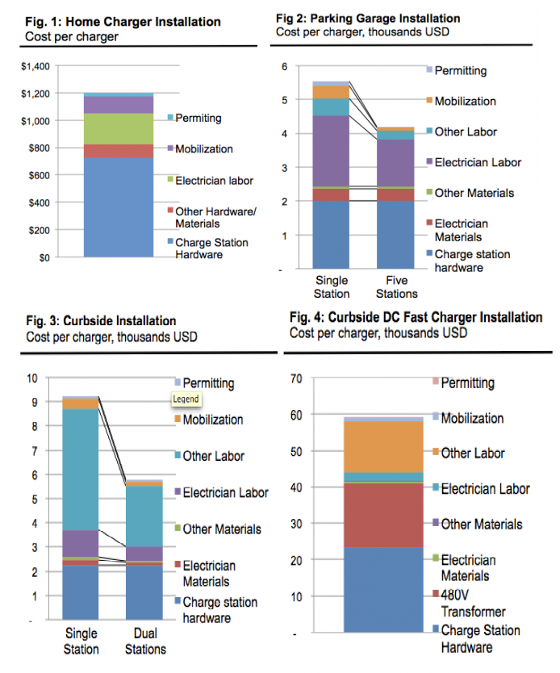

As it is seen charge station hardware cost and labor costs have the biggest shares of charging stations. While the charging station technology becoming advanced, other labor costs (other than electrician labor) increase. This shows that advancing technology in charging stations requires highly skilled human resources. Hardware costs in the future. Charging stations should be easy to setup and use in the future. But it is also solved by understanding the laws and regulations because usage of high level electricity related products covered by laws.

**EVs battery**

**Charging speed**

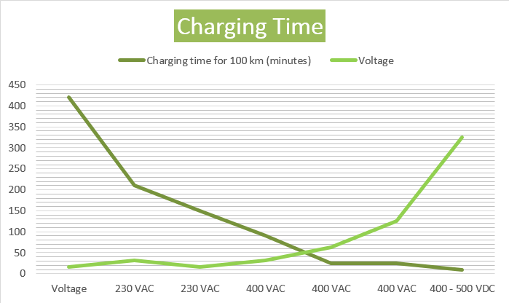

**Home battery**

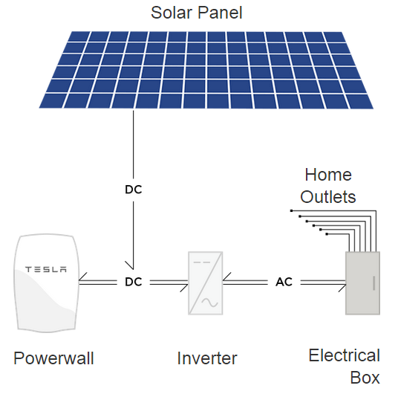

Tesla Energy developed an innovative product as home battery that is called Powerwall. “*Home battery that charges using electricity generated from solar panels, or when utility rates are low, and powers your home in the evening. Powerwall offers independence from the utility grid and the security of an emergency backup. Without a home battery, excess solar energy is often sold to the power company and purchased back in the evening. This mismatch adds demand on power plants and increases carbon emissions. Powerwall bridges this gap between renewable energy supply and demand by making your home’s solar energy available to you when you need it.”[2]* This innovative factor will have great impact on our understanding about energy market and grid systems most probably. After this kind of home batteries become common, EVs charger will not be just a bridge between grid and EVs. There will be three actors in the energy system as Smart Grid, home battery, EVs and all will be simply energy buyer and seller.

***[EVs chargers will not just connect grid to buy and sell electricity but also communicate and cooperate with home batteries to manage energy supply and demand of a house as being player of energy market.]***

**Maintenance**

Maintenance of EVs chargers is part of EVs maintenance in most cases of producers. Modern gasoline cars involves high number of big and small parts and this situation getting worse due to vehicles’ increasing complexity. This situation attracts high cost of labor for maintenance. Electric vehicles are no exception to this problem; however, they are still much cheaper to maintain due to their inherent simplicity.[3] Maintenance of charging stations requires diverse process according to type of station. It seem that advancements of these systems’ technology in the future may require high skilled labor but low cost of spare parts because of developments on manufacturing EVs charging stations.

**Payment system and Price**

**Blockchain technology**

**cost of charging station**

1. <http://blog.rmi.org/blog_2014_04_29_pulling_back_the_veil_on_ev_charging_station_costs>
2. <http://www.teslamotors.com/powerwall>
3. <http://cleantechnica.com/2012/12/18/ev-maintenance-much-cheaper-than-that-of-ice-vehicles/>